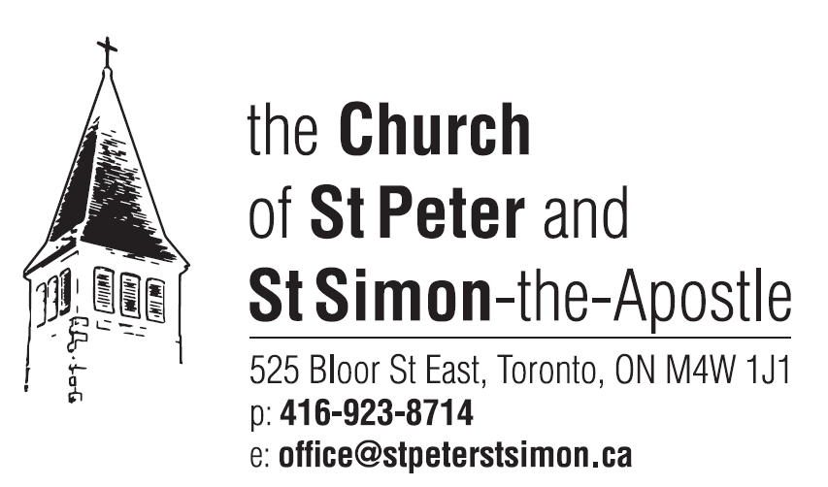

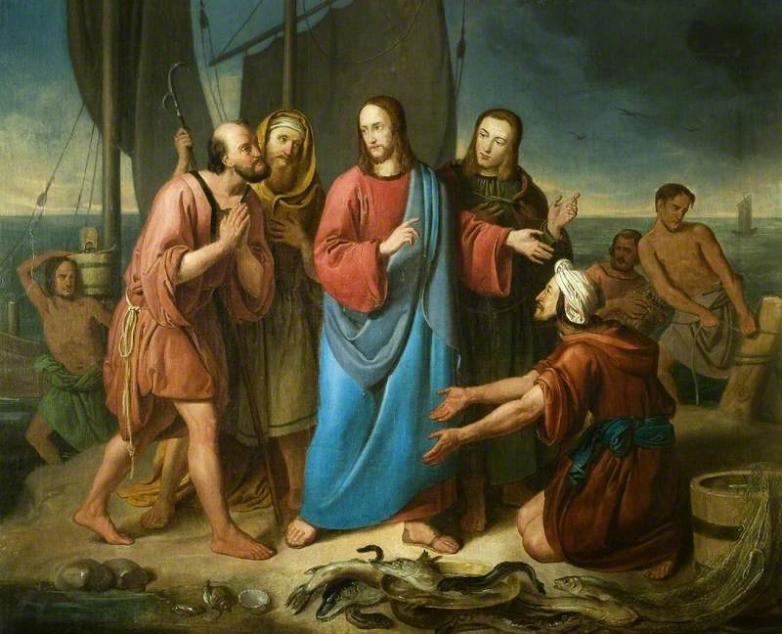
The Calling of the First Disciples
Adam Branner (1800-1891)
Leicester Museum and Art Gallery

The Third Sunday after the Epiphany
January 21, 2024

Welcome to the Church of St Peter and St Simon-the-Apostle.
The flowers in the sanctuary are given to the honour and glory of Almighty God
in thanksgiving for those who give their time and energy
in the parish for the ministry of hospitality,
especially coffee hour, funeral receptions and other occasions.

Holy Eucharist at 9.15 am.
Celebrated in the Chapel of the Holy Spirit.
BCP pp. 67ff
Celebrant The Reverend Canon Geoffrey Sangwine

Choral Eucharist at 10.30 am.
Celebrant The Reverend Canon Geoffrey Sangwine
Deacon & Preacher The Reverend Abraham Thomas
Servers
Communion Ministers
Director of Music Robin Davis
Organist Johan van ‘t Hof
Mass Setting Gloria/Creed - Merbecke
Sanctus/Benedictus, Agnus Dei - Missa de Sancta Maria Magdalena - Healey Willan

.
†††

Children going to Church School | Please gather at the entrance of the Church near the font to meet with Sileen Phillips, Children’s Ministry Co-ordinator, and Carol Peck.

The Gathering of the Community
Prelude Prelude in b minor Healey Willan

Hymn 383 Jesus Shall Reign Where’er the Sun Duke Street

Celebrant The grace of our Lord Jesus Christ and the love of God,
and the fellowship of the Holy Sprit be with you all.
All And with thy spirit.
Celebrant Almighty God,
All unto whom all hearts be open, all desires known, and from whom no secrets
are hid: cleanse the thoughts of our hearts by the inspiration of thy Holy Spirit, that we may perfectly love thee, and worthily magnify thy holy name;
through Christ our Lord. Amen.
Summary of the Law
Celebrant Our Lord Jesus Christ said: hear, O Israel, the Lord our God is one Lord;
and thou shalt love the Lord thy God with all thy heart,
and with all thy soul, and with all thy mind, and with all thy strength.
This is the first and great commandment. And the second is like unto it: thou shalt love thy neighbour as thyself. On these two commandments hang all the law and the prophets.
All Lord have mercy upon us, and write both these thy laws
in our hearts, we beseech thee.
Choir Kyrie eleison. Christe eleison. Kyrie eleison.
Lord have mercy upon us. Christ have mercy upon us.
Lord, have mercy upon us.

Gloria Hymn Book # 679 Merbecke
Celebrant Glory be to God on high,
All and in earth peace, good will towards all.
We praise thee, we bless thee, we worship thee, we glorify thee,
we give thanks to thee for thy great glory, O Lord God, heavenly King, God the Father Almighty. O Lord, the only-begotten Son, Jesu Christ;
O Lord God, Lamb of God, Son of the Father,
that takest away the sin of the world, have mercy upon us.
Thou that takest away the sin of the world, receive our prayer.
Thou that sittest at the right hand of God the Father, have mercy upon us.
For thou only art holy; thou only art the Lord; thou only, O Christ, with the Holy Ghost, art most high in the glory of God the Father. Amen.

Collect of the Day
Celebrant Almighty and everlasting God, mercifully look upon our infirmities,
and in all our dangers and necessities stretch forth thy right hand
to help and defend us; through Jesus Christ our Lord. Amen.

The Liturgy of the Word

First Reading Jonah 3.1-5,10 Read by Peggy Needham

Reader A reading from the Book of Jonah.

The word of the Lord came to Jonah a second time, saying, "Get up, go to Nineveh, that great city, and proclaim to it the message that I tell you." So Jonah set out and went to Nineveh, according to the word of the Lord. Now Nineveh was an exceedingly large city, a three days' walk across. Jonah began to go into the city, going a day's walk. And he cried out, "Forty days more, and Nineveh shall be overthrown!" And the people of Nineveh believed God; they proclaimed a fast, and everyone, great and small, put on sackcloth. When God saw what they did, how they turned from their evil ways, God changed his mind about the calamity that he had said he would bring upon them; and he did not do it.
Reader The word of the Lord.
All Thanks be to God.

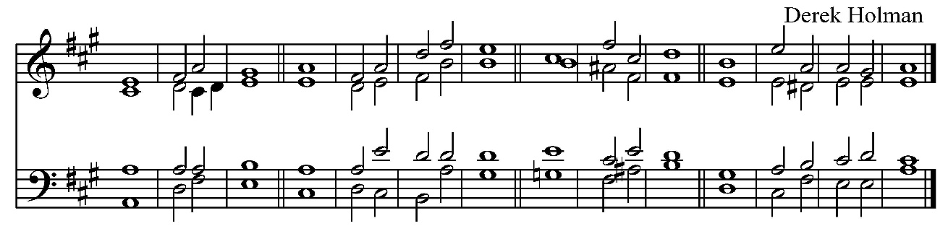
Psalm 62.5-12

⁵ My soul wait thou ˈ still upon ˈ God :
for my ˈ hope ˈ is in ˈ him.
⁶ He truly is my strength and ˈ my salˈvation :
he is my defence ˈ so that I ˈ shall not ˈ fall.
⁷ In God is my ˈ health and my ˈ glory :
the rock of my might, and in ˈ God is ˈ my ˈ trust.
⁸ O put your trust in him ˈ alway ye ˈ people :
pour out your hearts before him, for ˈ God is ˈ our ˈ hope.
⁹ As for the children of men ˈ they are but ˈ vanity :
yea the children of men are deceitful, upon the scales they are altogether ˈ lighter than ˈ vanity itˈself.
¹⁰ O trust not in wrong and robbery, give not yourselves ˈ unto ˈ vanity :
if riches increase ˈ set not your ˈ heart upˈon them.
¹¹ God spake once, and twice I have also ˈ heard the ˈ same :
that power beˈlongeth ˈ unto ˈ God;
¹² And that thou ˈ Lord art ˈ merciful :
for thou rewardest every one acˈcording ˈ to their ˈ work.

Epistle I Corinthians 7.29-31 Read by Ian Corlett
Reader A reading from the First Letter of Paul to the Corinthians.

I mean, brothers and sisters, the appointed time has grown short; from now on, let even those who have wives be as though they had none, and those who mourn as though they were not mourning, and those who rejoice as though they were not rejoicing, and those who buy as though they had no possessions, and those who deal with the world as though they had no dealings with it. For the present form of this world is passing away.
Reader The word of the Lord.
All Thanks be to God.
Gradual Hymn 430 Will You Come and Follow Me Kelvingrove
The Holy Gospel Mark 1.14-20
Deacon The Lord be with you.
All And with thy spirit.
Deacon The Holy Gospel of our Lord Jesus Christ according to St. Mark.
All Glory be to thee, O Lord.
Now after John was arrested, Jesus came to Galilee, proclaiming the good news of God, and saying, "The time is fulfilled, and the kingdom of God has come near; repent, and believe in the good news." As Jesus passed along the Sea of Galilee, he saw Simon and his brother Andrew casting a net into the sea - for they were fishermen. And Jesus said to them, "Follow me and I will make you fish for people." And immediately they left their nets and followed him. As he went a little farther, he saw James son of Zebedee and his brother John, who were in their boat mending the nets. Immediately he called them; and they left their father Zebedee in the boat with the hired men, and followed him.
Gospeller The Gospel of Christ.
All Praise be to thee, O Christ.
Homily The Reverend Abraham Thomas
Nicene Creed – Hymn Book #681 Please stand. Merbecke
Celebrant I believe in one God,
All the Father almighty, maker of heaven and earth,
and of all things visible and invisible;
And in one Lord Jesus Christ, the only-begotten Son of God,
begotten of the Father before all worlds,
God, of God; Light, of Light; very God, of very God;
begotten, not made; being of one substance with the Father;
through whom all things were made:
who for us and for our salvation came down from heaven,
and was incarnate by the Holy Ghost of the Virgin Mary,
and was made man, and was crucified also for us under Pontius Pilate.
He suffered and was buried, and the third day he rose again according to the scriptures, and ascended into heaven,
and sitteth on the right hand of the Father.
And he shall come again with glory to judge both the quick and the dead: whose kingdom shall have no end.
And I believe in the Holy Ghost, the Lord, the giver of life,
who proceedeth from the Father and the Son,
who with the Father and the Son together is worshipped and glorified,
who spake by the prophets. And I believe one, holy, catholic, and apostolic Church. I acknowledge one baptism for the remission of sins.
And I look for the resurrection of the dead, and the life of the world to come. Amen.

Prayers of the People Please kneel or stand. Led by Peggy Needham
Confession and Absolution
The Celebrant invites the congregation to join in the General Confession.
Silence is kept. Please kneel or be seated.

Celebrant Almighty God,
All Father of our Lord Jesus Christ, maker of all things and judge of all people:
we acknowledge and confess our manifold sins and wickedness,
which we from time to time most grievously have committed,
by thought, word and deed, against thy divine majesty.
We do earnestly repent, and are heartily sorry for these our misdoings.
Have mercy upon us, most merciful Father;
for thy Son our Lord Jesus Christ’s sake, forgive us all that is past;
and grant that we may ever hereafter serve and please thee
in newness of life, to the honour and glory of thy name;
through Jesus Christ our Lord. Amen.
The absolution is pronounced. Then all stand.
The Peace
Celebrant The peace of the Lord be always with you.
All And with thy spirit.
The Celebration of the Eucharist
Offertory Hymn 273 Sing of Andrew, John’s Disciple Abbott’s Leigh
Prayer over the Gifts
Celebrant Loving God, before the world began you called us. Make holy all we offer this day and strengthen us in that calling. We ask this in the name of Jesus Christ the Lord. Amen.
The Great Thanksgiving - Hymn Book # 683
Celebrant The Lord be with you.
All And with thy spirit.
Celebrant Lift up your hearts.
All We lift them up unto the Lord.
Celebrant Let us give thanks unto our Lord God.
All It is meet and right so to do.
Celebrant It is very meet, right, and our bounden duty, that we should at all times,
and in all places, give thanks unto thee, O Lord, holy Father, almighty, everlasting God, creator and preserver of all things. Through Jesus Christ our Lord, who, in substance of our mortal flesh, manifested forth his glory, that he might bring us out of darkness into his own marvellous light. Therefore with angels and archangels, and with all the company of heaven, we laud and magnify thy glorious name; evermore praising thee and saying:
All Holy, holy, holy, Lord God of Hosts, heaven and earth are full of thy glory. Glory be to thee, O Lord most high. Blessed is he that cometh in the name of the Lord: Hosanna in the highest. All kneel or be seated.
Celebrant Blessing and glory and thanksgiving be unto thee, almighty God, our heavenly Father, who of thy tender mercy didst give thine only Son Jesus Christ to take our nature upon him, and to suffer death upon the cross for our redemption; who made there, by his one oblation of himself once offered, a full, perfect, and sufficient sacrifice, oblation, and satisfaction, for the sins of the whole world; and did institute, and in his holy Gospel command us to continue, a perpetual memorial of that his precious death, until his coming again. Hear us, O merciful Father, we most humbly beseech thee; and grant that we receiving these thy creatures of bread and wine, according to thy Son our Saviour Jesus Christ’s holy institution, in remembrance of his death and passion, may be partakers of his most blessed body and blood; who, in the same night that he was betrayed, took bread; and, when he had given thanks, he brake it; and gave it to his disciples, saying, “Take, eat; this is my body which is given for you: Do this in remembrance of me.” Likewise after supper he took the cup; and when he had given thanks, he gave it to them, saying, “Drink ye all, of this; for this is my blood of the new covenant, which is shed for you and for many for the remission of sins: Do this, as oft as ye shall drink it, in remembrance of me.” Wherefore, O Father, Lord of heaven and earth, we thy humble servants, with all thy holy Church, remembering the precious death of thy beloved Son, his mighty resurrection, and glorious ascension, and looking for his coming again in glory, do make before thee, in this sacrament of the holy bread of eternal life and the cup of everlasting salvation, the memorial which he hath commanded: And we entirely desire thy fatherly goodness mercifully to accept this our sacrifice of praise and thanksgiving, most humbly beseeching thee
to grant, that by the merits and death of thy Son Jesus Christ, and through faith in his blood, we and all thy whole Church may obtain remission of our sins, and all other benefits of his passion; and we pray that by the power of thy Holy Spirit, all we who are partakers of this holy communion may be fulfilled with thy grace and heavenly benediction; through Jesus Christ our Lord, by whom and with whom,
in the unity of the Holy Spirit, all honour and glory be unto thee, O Father Almighty, world without end. Amen.

Lord’s Prayer – Sung together
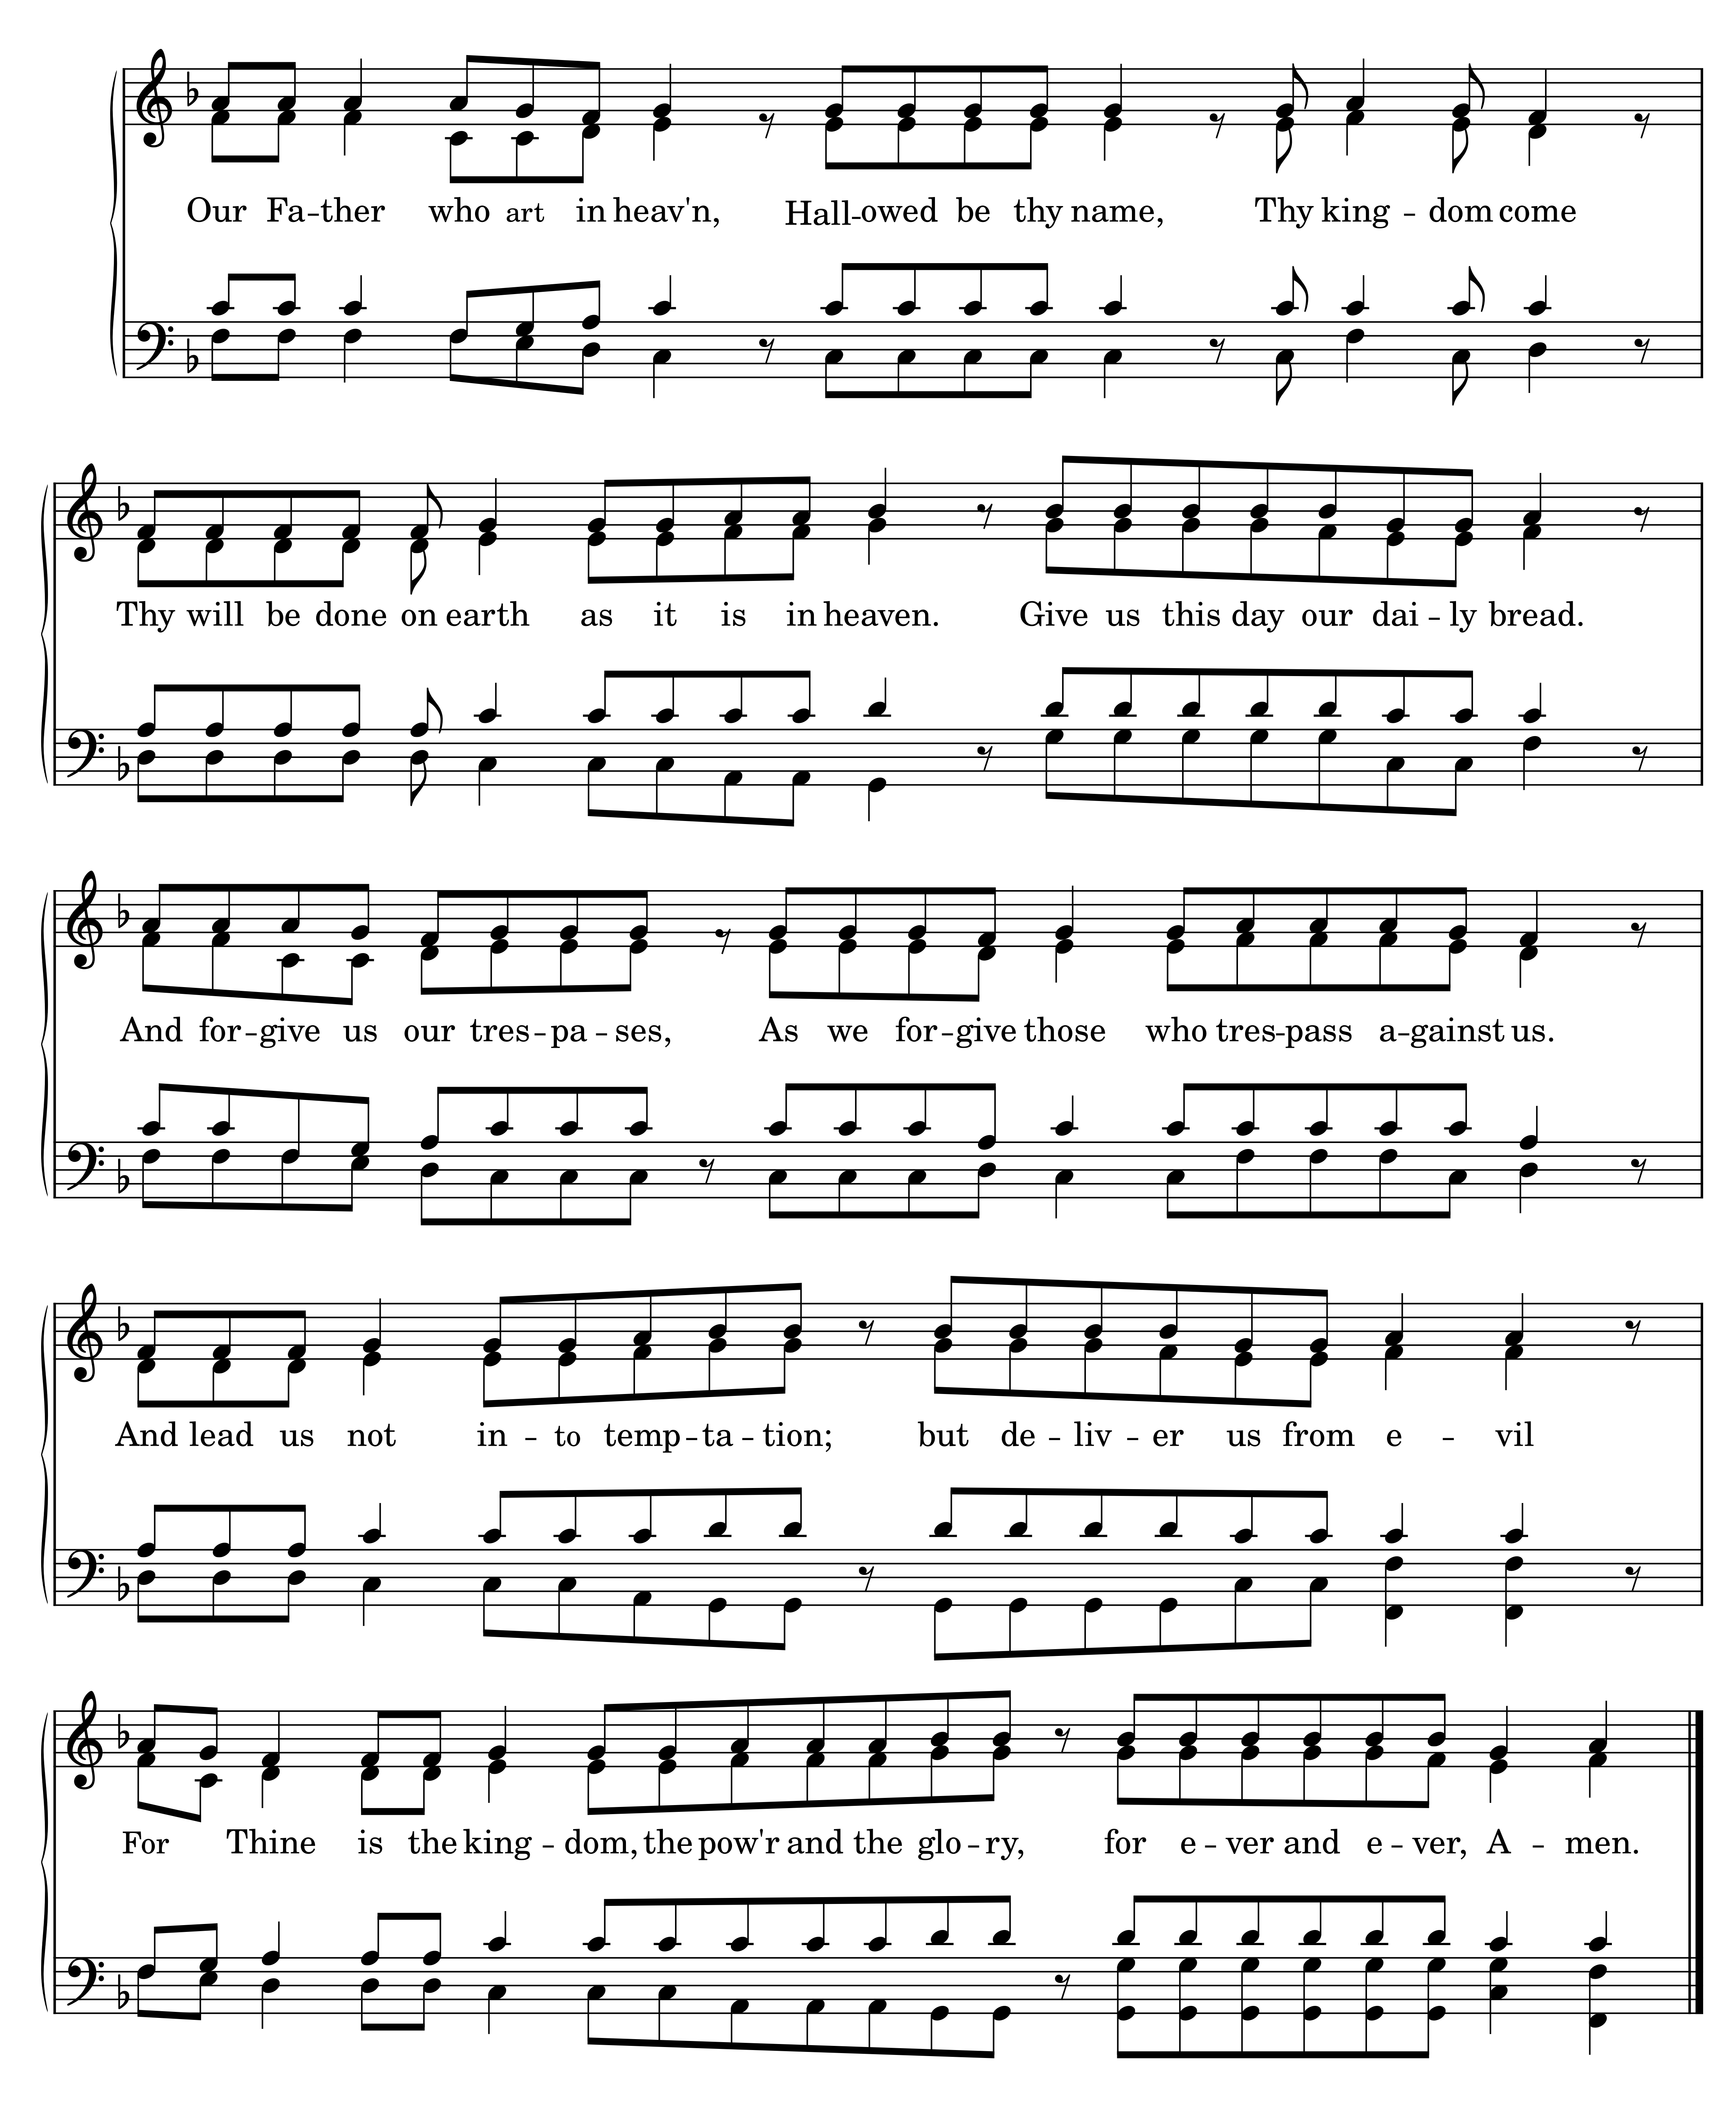

\

Breaking of the Bread
Celebrant We break the bread of life, and that life is the light of the world.
All God here among us, light in the midst of us, bring us to light and life.
Celebrant The gifts of God for the People of God.
All Thanks be to God.

Agnus Dei
All O Lamb of God, who takes away the sin of the world, have mercy on us.
O Lamb of God, who takes away the sin of the world, have mercy on us.
O Lamb of God, who takes away the sin of the world, grant us your peace.
Holy Communion
- Holy Communion will be administered at both the High Altar and at the St Peter’s Altar (standing). If you are communicating at the High Altar, please return to your pew through the side Sacristy door.
- Communion is administered in both kinds, bread and wine. Please do not intinct (dip the wafer in the wine). The fullness of the sacrament is present in the bread only. If you are not receiving the chalice, you may touch the base while the words of administration are spoken.
- If you would like only a blessing, please cross your arms over your chest to indicate this to the priest.
A Prayer for Spiritual Communion (The Prayer of St Richard of Chichester – adapted)
For those not receiving the sacrament we commend this prayer for Spiritual Communion.
Thanks be to you, Lord Jesus Christ, for all the benefits you have given me,
for all the pains and insults you have borne for me.
Since I cannot now receive you sacramentally, I ask you to come spiritually into my heart. O most merciful redeemer, friend and brother, may I know you more clearly,
love you more dearly, and follow you more nearly, day by day. Amen.

Communion Hymn 78 Deck Thyself, My Soul, With Gladness SchmÜcke Dich

Motet O Lord, Thou Hast Searched Me Out and Known Me (Psalm 139 KJV) Bob Chilcott
O Lord, thou hast searched me out, and known me.
Thou knowest my downsitting and mine uprising,
thou understandest my thought afar off.
Thou compassest my path and my lying down,and art acquainted with all my ways.
For there is not a word in my tongue, but, lo, 0 Lord, thou knowest it altogether.
Thou hast beset me behind and before, and laid thine hand upon me.
Such knowledge is too wonderful for me; it is high, I cannot attain unto it.
Whither shall I go from thy spirit? or whither shall I flee from thy presence?
If I ascend into heaven, thou art there; if I make my bed in hell, behold,
thou art there.
If I take the wings of the morning, and dwell in the uttermost parts of the sea;
Even there shall thy hand lead me, and thy right hand shall hold me.

Thanksgiving after Communion
Celebrant Lord our God, grant us grace to desire thee with our whole heart;
that so desiring, we may seek and find thee; and so finding, may love thee;
and so loving, may give thanks to thee for our redemption
through the cross of our Lord and Saviour Jesus Christ.
All Almighty God, we thank thee for feeding us
with the body and blood of thy Son, Jesus Christ.
Through him we offer unto thee ourselves our souls and bodies
to be a living sacrifice. Send us out in the power of the Spirit
to live and work for thy praise and glory. Amen.
Blessing
Announcements
Recessional Hymn All My Hope on God Is Founded Michael
1 All my hope on God is founded;  he doth still my trust renew.  Me through change and chance he guideth,  only good and only true.  God unknown, he alone,  calls my heart to be his own. | 2 Human pride and earthly glory,  sword and crown betray his trust;  what with care and toil he buildeth,  tower and temple, fall to dust.  But God's power, hour by hour,  is my temple and my tower.
3 God's great goodness aye endureth,  deep his wisdom, passing thought:  splendour, light, and life attend him,  beauty springeth out of naught.  Evermore from his store  new-born worlds rise and adore. | 4 Daily doth th' Almighty giver  bounteous gifts on us bestow;  his desire our soul delighteth,  pleasure leads us where we go.  Love doth stand at his hand;  joy doth wait on his command.
5 Still from earth to God eternal
sacrifice of praise be done,
high above all praises praising
for the gift of Christ his Son.
Christ doth call one and all:
ye who follow shall not fall.

Dismissal
Deacon Followers of Jesus Christ, inspired by the Holy Spirit, serve the world God loves.
All Thanks be to God. Alleluia!
Postlude Caprice sur les grand jeux. Louis-Nicolas ClÉrambault

CCLI License Number: 20651739

A Word from the Rector

St Augustine once said, “those who sing pray twice”. Today we are introducing a sung version of the Nicene Creed. We are using the same setting we use for the Gloria – by John Merbecke and both are in our hymn book. At one time, the liturgy was sung primarily by clergy, cantors and choir. A notable feature of the Reformation was the inclusion of congregational participation. Merbecke was deeply rooted in the ancient tradition of the Church while being dedicated to liturgical reform. This is reflected in his liturgical music intended for congregations, with melodies adapted from Gregorian Chant. He was a chorister at St George’s Chapel, Windsor and became organist until his death in 1585. I hope we will add this to our congregational repertoire at particular times and seasons, and that it will give us a different, hopefully meaningful way to affirm our faith.

Next Sunday I am participating in our annual pulpit exchange with neighbouring churches. I will preach at Rosedale Presbyterian, the Reverend Daniel Cho will be at St Andrew’s and the Reverend Neil Young from St Andrew’s will be here. It will be a service of Choral Matins which will replace the regular Matins on the second Sunday of the month in February.

I invite you to join us back here at 5 pm today for our performance of Amahl and the Night Visitors. GNS+

Parish Announcements

Coffee Hour | We hope you will join us for coffee hour which is in the Parish Hall immediately after the service. If you would like to help with this important ministry of hospitality please speak with Fran Brown or Laurie Sanderson.

Ice Skating at Brickworks | Today at 1 pm. All are invited. Skate rentals are available.

Amhal and the Night Visitors | Performance this afternoon at 5.00 pm here at SPSS.

Altar Flowers | We are inviting members of the congregation to provide memorial/thanksgiving altar flowers. Available date in January is 28.
Please contact the Church Office or Sheila Thomas, 416.921.259.

Ordination to the Priesthood of the Reverend Abraham Thomas
The Feast of the Presentation (Candlemas) Friday, February 2, 2024 at 7 pm.
Reception to follow in the Parish Hall.
The Rt. Rev’d Kevin Robertson, Celebrant
The Rev’d Canon Mark Regis, Preacher

Pancake Supper | Tuesday, February 13th. Join us as we enjoy a delicious meal of pancakes and sausages, with special music by Isaak Bonk.

Ash Wednesday | Wednesday, February 14th. Sung Eucharist at 11 am; Choral Eucharist at 7 pm. The imposition of ashes will be offered at both services.

In collaboration with
The Church of St. Peter and St. Simon-the-Apostle
Presents…
AMAHL AND THE NIGHT VISITORS
By Gian Carlo Menotti

In Concert Today
SUNDAY, JANUARY 21, 2024 at 5:00 pm

The Church of St. Peter and St. Simon-the-Apostle
525 Bloor Street East, Toronto
Admission: $5-$25
Tickets also on
WWW.NOSTRINGSTHEATRE.COM
or call 416-652-0230
Proceeds to support the Children’s Ministry at SPSS & No Strings Theatre
Featuring
Zev Stone (Boy) Denise Williams (Mother)
Ian Corlett (Kaspar) Geoffrey Sangwine (Melchior)
Daniel Lagover (Balthazar) Alex Chan (Page)
Musically directed by William Shookhoff
Choreographed by Kathleen Mills
Hazel Boyle, oboe
The Church of St. Peter and St. Simon-the-Apostle
525 Bloor St E, Toronto, ON M4W 1J1
416.923.8714 www.stpeterstsimon.ca www.facebook.com/stpeterstsimons

CLERGY, WARDENS & STAFF  Incumbent The Reverend Canon Geoffrey Sangwine,  option 1; incumbent@stpeterstsimon.ca; Mobile: 416.720.2099  Assistant Curate The Reverend Abraham Thomas  416-316-3497  Honorary Assistant  The Reverend Canon Michael Burgess  Director of Music Robin Davis 905.409.6121  robin.davis@rogers.com  Honorary Assistant Organists  Johan van 't Hof / Alison Jane  Wardens David Carrington – Rector’s Warden  dcarrington.omers@sympatico.ca  Stephanie Woodside – People’s Warden  swoodside27@gmail.com  Deputy Wardens Gerry Courage, Laurie Sanderson,  Vanessa Scott, Johan van't Hof  Treasurer Johan van't Hof, 647.202.9985  jvanthof@tonbridgecorp.com  Sexton Daiverzon Guillermo, 647.863.0698 davenguillermo7@yahoo.com  Children’s Ministry Sileen Phillips  647.718.6728 kidscoordinator@yahoo.com  Parish Administrator Jessy Balendra,  office@stpeterstsimon.ca  Church Office Hours Tuesday, Wednesday, and Thursday, 9 am to 5pm. | PARISH MINISTRIES  Advisory Board Chair Matthew Beasley  mbeesley@yahoo.com  Altar Guild Joy Quan-Lee, Sheila Thomas,  Marie Samuels-Isaac  Community Connections Fran Brown  f.brown026@outlook.com  Envelope Secretary Paul Mitchell  647.343.0173 pablo51@rogers.com  Flowers Sheila Thomas, Joy Quan-Lee  Health and Safety Committee Ted Robinson  ted55robinson@gmail.com  Hospitality Fran Brown f.brown-026@outlook.com  Intercessors Ian Corlett  Jubilate Newsletter Vanessa Scott  scottvanessa@gmail.com  Pre-Authorized Giving (PAG) Robert Sloan  robertdsloan@gmail.com  Property Committee Larry Krotz l.krotz@sympatico.ca  Readers Daphne Harris daphneharris@sympatico.ca  Rentals License Groups Church Office  office@stpeterstsimon.ca  Responsible Ministry Irene Courage/The Rector  Servers Fen Nanton  Sidespersons John Pugsley johnapugsley@gmail.com  Stewardship Committee Moveta Nanton 416-493-2805  moveta.nanton@gmail.com  Technical Ministry David Carrington/Melica Smith  Verger Ian Corlett kingherodspeaks@protonmail.com

We acknowledge that in gathering to worship Almighty God,
we are in the traditional territory of many First Nations peoples
including the Mississaugas of the New Credit,
the Anishinaabe, the Haudenosaunees, and the Huron-Wendat.
"The earth is the Lord’s, and all that therein is, the world and all who dwell therein.” Psalm 24.1.

