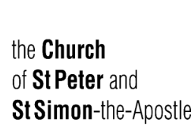
Fifteenth Sunday after Pentecost
September 10, 2023

Welcome to the church of St Peter and St Simon-the-Apostle
Holy Eucharist at 9.15 am.
(In the Chapel of the Holy Spirit)
The service begins on page 67 of the Book of Common Prayer.

Sung Matins at 10:30 am.
Officiant & Preacher: The Reverend Canon Geoffrey Sangwine
Honorary Assistant: The Reverend Canon Michael Burgess

Organist Director of Music: Robin Davis
Honorary Associate Organist: Johan van ‘t Hof
The flowers are given to the honour and glory of Almighty God
and in loving memory of his mother Lisette Powell, by Kevin Sinclair.

___________________________________________________________________________

The service begins on page 1 of the Book of Common Prayer.
Prelude Herzliebster Jesu (Ah Jesus dear) JOHANNES BRAHMS

Processional Hymn 349 All People That On Earth Do Dwell Old 100th Arr. Ralph Vaughn Williams

All people that on earth do dwell,
sing to the Lord with cheerful voice,
Him serve with fear, his praise forth tell;
come ye before him, and rejoice.

The Lord, ye know, is God indeed,
without our aid he did us make;
we are his folk, he doth us feed,
and for his sheep he doth us take.
O enter then his gates with praise,
approach with joy his courts unto;
Praise, laud, and bless his name always,
for it is seemly so to do.
For why? the Lord our God is good;
His mercy is forever sure;
His truth at all times firmly stood,
And shall from age to age endure.

To Father, Son, and Holy Ghost,
the God whom heaven and earth adore,
from all and from the angel host,
be praise and glory ever more. Amen.

Opening Sentences – BCP p. 1-2
Invitation to Confession – BCP p. 4
General Confession & Absolution – BCP p. 4-5 Please kneel or be seated
Officiant Almighty and most merciful Father,
All We have erred and strayed from thy ways like lost sheep,
we have followed too much the devices and desires of our own hearts,
we have offended against thy holy laws,
We have left undone those things which we ought to have done,
and we have done those things which we ought not to have done;
and there is no health in us. But thou, O Lord, have mercy upon us,
miserable offenders. Spare thou them, O God, which confess their faults.
Restore thou them that are penitent; according to thy promises
declared unto all people in Christ Jesu our Lord.
And grant, O most merciful Father, for his sake, that we may hereafter
live a godly, righteous, and sober life, to the glory of thy holy Name. Amen.

The Absolution – BCP p. 5
Officiant Almighty God, the Father of our Lord Jesus Christ, who desireth not the death of sinners, but rather that they may turn from their wickedness, and live, hath given power and commandment to his Ministers, to declare and pronounce to his people, being penitent, the Absolution and Remission of their sins. He pardoneth and absolveth all them that truly repent and unfeignedly believe his holy Gospel. Wherefore we beseech him to grant us true repentance and his Holy Spirit, that those things may please him which we do at this present, and that the rest of our life hereafter may be pure and holy; so that at the last we may come to his eternal joy; through Jesus Christ our Lord. Amen.

The Lord’s Prayer – BCP pp. 5-6

Versicles & Responses – BCP p. 6
Officiant O Lord, open thou our lips;
All And our mouth shall show forth thy praise.
Officiant O God, make speed to save us;
All O Lord, make haste to help us. All stand.
Officiant Glory be to the Father, and to the Son, and to the Holy Ghost;
All As it was in the beginning, is now, and ever shall be, world without end. Amen.
Officiant Praise ye the Lord;
All The Lord’s Name be praised.
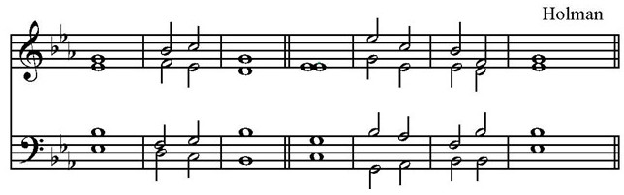
The Venite – Psalm 95 BCP pp. 6-7 Sung by all, standing.

The Lord God omnipotent reigneth:/ O come, let us worship.
O come, let us |sing unto ⋅ the | Lord: /
* let us heartily rejoice in the |strength of |our sal |vation.
Let us come before his | presence with | thanksgiving /
* and show ourselves | glad in | him with | psalms.
For the Lord is a | great | God /
* and a great | King a ⋅ bove | all | gods.
In his hand are all the | corners ⋅ of the | earth /
* and the | strength of ⋅ the | hills is ⋅ his | also.
The sea is | his and ⋅ he | made it /
* and his | hands pre | pared the ⋅ dry | land.
O come, let us worship and | fall | down /
* and | kneel be ⋅ fore the | Lord, our | Maker.
For he is the | Lord our | God /
* and we are the people of his pasture, | and the | sheep of ⋅ his | hand.
To-day, O that ye would | hear his | voice: /
* ‘Harden not your hearts as in the Provocation, and as in the day of Temp | tation |
in the |wilderness
When your fathers | tempted | me, /
* proved | me, and | saw my | works.
Forty years long was I grieved with that gene | ration, and | said, /
* “It is a people that do err in their hearts, for they | have not | known my | ways”;
Unto whom I | sware in my | wrath, /
* that they should not | enter | into my | rest.’
Glory be to the Father, and | to the | Son, * and | to the | Holy | Ghost;
As it was in the beginning, is now, and | ever | shall be, * world without | end. | A- | men.
The Lord God omnipotent reigneth:/ O come, let us worship.

The First Lesson Exodus 12.1-14 Read by Paul Falkner
Reader The first lesson is written in the 12th chapter of the Book of Exodus, beginning at the 1st verse.

The Lord said to Moses and Aaron in the land of Egypt: This month shall mark for you the beginning of months; it shall be the first month of the year for you. Tell the whole congregation of Israel that on the tenth of this month they are to take a lamb for each family, a lamb for each household. If a household is too small for a whole lamb, it shall join its closest neighbour in obtaining one; the lamb shall be divided in proportion to the number of people who eat of it. Your lamb shall be without blemish, a year old male; you may take it from the sheep or from the goats. You shall keep it until the fourteenth day of this month; then the whole assembled congregation of Israel shall slaughter it at twilight. They shall take some of the blood and put it on the two doorposts and the lintel of the houses in which they eat it. They shall eat the lamb that same night; they shall eat it roasted over the fire with unleavened bread and bitter herbs. Do not eat any of it raw or boiled in water, but roasted over the fire, with its head, legs, and inner organs. You shall let none of it remain until the morning; anything that remains until the morning you shall burn. This is how you shall eat it: your loins girded, your sandals on your feet, and your staff in your hand; and you shall eat it hurriedly. It is the passover of the Lord. For I will pass through the land of Egypt that night, and I will strike down every firstborn in the land of Egypt, both human beings and animals; on all the gods of Egypt I will execute judgements: I am the Lord. The blood shall be a sign for you on the houses where you live: when I see the blood, I will pass over you, and no plague shall destroy you when I strike the land of Egypt. This day shall be a day of remembrance for you. You shall celebrate it as a festival to the Lord; throughout your generations you shall observe it as a perpetual ordinance.
Reader The word of the Lord.
All Thanks be to God.

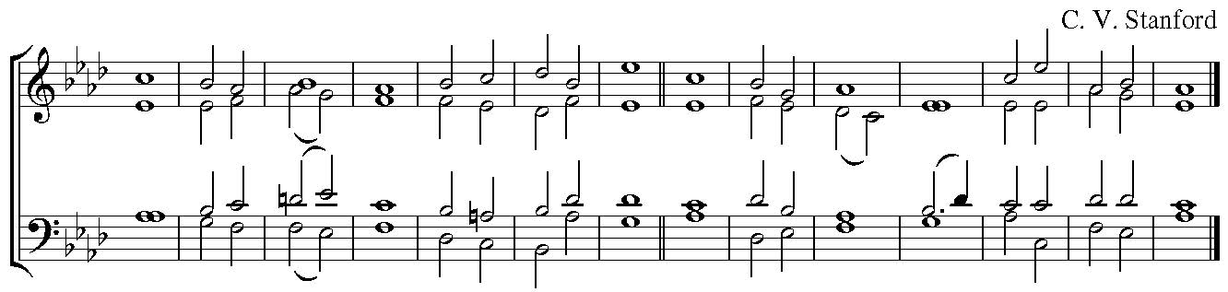
Psalm 149 Contate Domino.
¹ O SING unto the | Lord a ˖ new | song:
* let the congre | gation of | saints | praise him.
² Let Israel rejoice in | him that | made him:
*and let the children of Sion be | joyful | in their | King.
³ Let them praise his | Name ˖ in the | dance:
*let them sing praises unto | him with | timbrel and | harp.
⁴ For the Lord hath | pleasure ˖ in his | people,
*and adorneth the | humble | with sal | vation.
⁵ Let the saints be | joyful with | glory:
*let them sing for | joy up | on their | couches.
⁶ Let the praises of God be | in their | mouth,
*and a | two-edged | sword ˖ in their | hands;
⁷ To be a |venged ˖ of the | nations,
*and | to re | buke the | peoples;
⁸ To bind their | kings in | chains,
*and their | nobles with | links of | iron;
2^{nd 9} To execute upon them the | judgement ˖ that is | written.
*Such | honour have | all his | saints.
Glory be to the Father, and | to the | Son,
* and | to the | Holy | Ghost;
As it was in the beginning, is now, and | ever | shall be,
* world without | end. A| - - | men.

The Second Lesson Romans 13.8-14 Read by Marc Côté
Reader The second lesson is written in the 13th chapter of the Epistle of St Paul to the Romans, beginning at the 8th verse.

Owe no one anything, except to love one another; for the one who loves another has fulfilled the law. The commandments, "You shall not commit adultery; You shall not murder; You shall not steal; You shall not covet"; and any other commandment, are summed up in this word, "Love your neighbour as yourself." Love does no wrong to a neighbour; therefore, love is the fulfilling of the law. Besides this, you know what time it is, how it is now the moment for you to wake from sleep. For salvation is nearer to us now than when we became believers; the night is far gone, the day is near. Let us then lay aside the works of darkness and put on the armour of light; let us live honourably as in the day, not in revelling and drunkenness, not in debauchery and licentiousness, not in quarrelling and jealousy. Instead, put on the Lord Jesus Christ, and make no provision for the flesh, to gratify its desires.
Reader The word of the Lord.
All Thanks be to God.

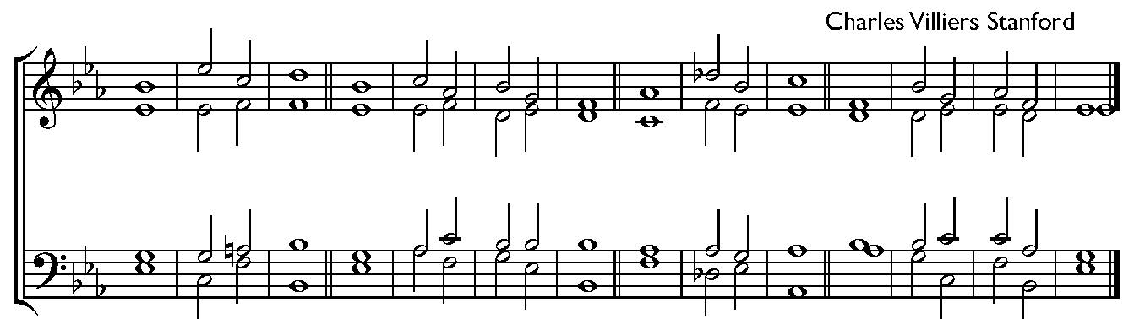
Te Deum

We praise ˈ thee, O ˈ God; / we acknowledge ˈ thee to ˈ be the ˈ Lord.
All the ˈ earth doth ˈ worship thee, / the ˈ Father ˈ ever ˈ lasting.
To thee all angels ˈ cry aˈloud / the heavens and ˈ all the ˈ powers thereˈin.
To thee ˈ cherubim and ˈ seraphim / conˈtinualˈly do ˈ cry
Holy ˈ holy ˈ holy / Lord ˈ God ˈ of ˈ hosts;
Heaven and ˈ earth are ˈ full / of the ˈ majes⋅ty ˈ of thy ˈ glory.
The glorious company of the aˈpostles ˈ praise thee /
the goodly fellowship ˈ of the ˈ prophets ˈ praise thee;
The noble army of ˈ martyrs ˈ praise thee, /
The holy church throughout all the world ˈ doth acˈknowledge ˈ thee,
2nd The Father, of an ˈ infinite ˈ majesty / thine honourable, true and only Son; also the ˈ
Holy ˈ Ghost, the ˈ Comforter.
Thou art the King of ˈ glory, O ˈ Christ. / Thou art the everˈlasting ˈ Son of ⋅ the ˈ Father.
When thou tookest upon thee to deˈliver ˈ man /
Thou didst not abˈhor the ˈ Virgin’s ˈ womb.
When thou hadst overcome the ˈ sharpness of ˈ death /
thou didst open the kingdom of ˈ heaven to ˈ all beˈlievers.
Thou sittest at the right hand of God, in the ˈ glory ⋅ of the ˈ Father. /
We believe that thou shalt ˈ come to ˈ be our ˈ judge.
We therefore pray thee, ˈ help thy ˈ servants /
whom thou hast redeemed ˈ with thy ˈ precious ˈ blood.
Make them to be numbered ˈ with thy ˈ saints / in ˈ glory ˈ everˈlasting.
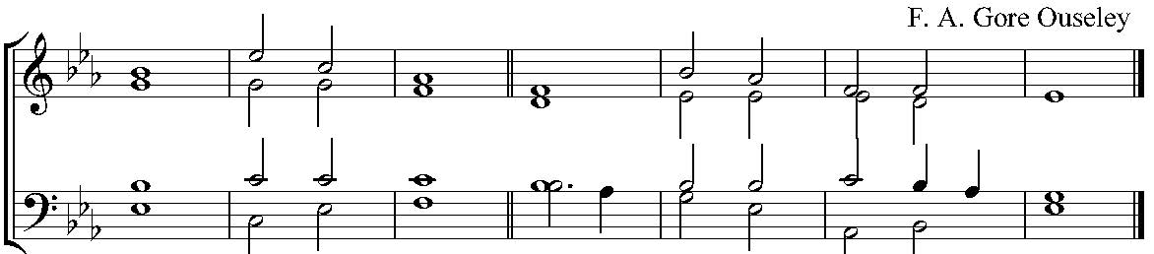

O Lord save thy people and ˈ bless thine ˈ heritage; /
Govern them and ˈ lift them ˈ up for ˈ ever.
Day by day we ˈ magni-fy ˈ thee; / and we worship thy Name, ˈ ever ˈ world with-out ˈ end.
Vouchsafe O Lord to keep us this ˈ day with-out ˈ sin. /
O Lord have mercy up ˈ on us, have ˈ mercy up ˈ on us.
O Lord let thy mercy lighten upon us, as our ˈ trust is ⋅ in ˈ thee. /
O Lord, in thee have I trusted: let me ˈ never ˈ be con ˈ founded.

Third Reading Matthew 18.15-20 Read by the Reverend Canon Michael Burgess
Reader The third lesson is written in the 18th chapter of the Gospel according to St Matthew, beginning at the 15th verse.
Jesus said, "If another member of the church sins against you, go and point out the fault when the two of you are alone. If the member listens to you, you have regained that one. But if you are not listened to, take one or two others along with you, so that every word may be confirmed by the evidence of two or three witnesses. If the member refuses to listen to them, tell it to the church; and if the offender refuses to listen even to the church, let such a one be to you as a Gentile and a tax collector. Truly I tell you, whatever you bind on earth will be bound in heaven, and whatever you loose on earth will be loosed in heaven. Again, truly I tell you, if two of you agree on earth about anything you ask, it will be done for you by my Father in heaven. For where two or three are gathered in my name, I am there among them."
Reader The word of the Lord.
All Thanks be to God.
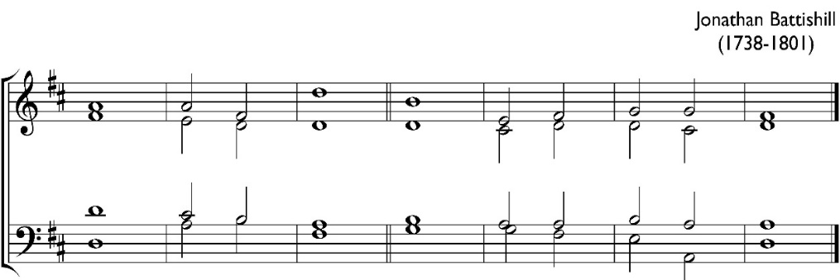
Jubilate Deo Sung by all. Please stand.

¹ O be joyful in the Lord, ˈ all ye ˈ lands:
* serve the Lord with gladness, and come before his ˈ presence ˈ with a ˈ song.
² Be ye sure that the ˈ Lord ⋅ he is ˈ God;
* it is he that hath made us, and not we ourselves; we are his people, ˈ
and the ˈ sheep of ⋅ his ˈ pasture.
³ O go your way into his gates with thanksgiving, and into his ˈ courts with ˈ praise;
* be thankful unto him, ˈ and speak ˈ good of ⋅ his ˈ Name.
⁴ For the Lord is gracious, his mercy is ˈ ever ˈ lasting;
* and his truth endureth from gene ˈ ration to ˈ gene ˈ ration.
Glory be to the Father, and ˈ to the ˈ Son, * and ˈ to the ˈ Holy ˈ Ghost;
As it was in the beginning, is now, and ˈ ever ˈ shall be, * world without ˈ end. A ˈ- - ˈ men.

The Apostles’ Creed – BCP pp. 10-11
Officiant I believe in God
All the Father Almighty, maker of heaven and earth: and in Jesus Christ his only Son our Lord, who was conceived by the Holy Ghost, born of the Virgin Mary, suffered under Pontius Pilate, was crucified, dead, and buried: he descended into hell; the third day he rose again from the dead; he ascended into heaven, and sitteth on the right hand of God the Father Almighty; from thence he shall come to judge the quick and the dead. I believe in the Holy Ghost; the holy Catholic Church; the Communion of Saints; the Forgiveness of sins; the Resurrection of the body, and the Life everlasting. Amen.
Officiant The Lord be with you;
All And with thy spirit.
Officiant Let us pray. Please kneel or be seated.
Officiant Lord, have mercy upon us.
All Christ, have mercy upon us.
Officiant Lord, have mercy upon us.

Officiant Our Father
All who art in heaven, hallowed be thy name, thy kingdom come,
thy will be done, on earth as it is in heaven.
Give us this day our daily bread; and forgive us our trespasses,
as we forgive them that trespass against us; and lead us not into temptation,
but deliver us from evil. Amen.

Officiant O Lord, show thy mercy upon us;
All And grant us thy salvation.
Officiant O Lord, save the King;
All And mercifully hear us when we call upon thee.
Officiant Endue thy ministers with righteousness;
All And make thy chosen people joyful.
Officiant O Lord, save thy people;
All And bless thine inheritance.
Officiant Give peace in our time, O Lord;
All And evermore mightily defend us.
Officiant O God, make clean our hearts within us;
All And take not thy Holy Spirit from us.

The Collects
Officiant ALMIGHTY and everlasting God, give unto us the increase of faith, hope, and charity; and, that we may obtain that which thou dost promise, make us to love that which thou dost command; through Jesus Christ our Lord. Amen.
Officiant O GOD, who art the author of peace and lover of concord, in knowledge of whom standeth our eternal life, whose service is perfect freedom: defend us thy humble servants in all assaults of our enemies; that we, surely trusting in thy defence, may not fear the power of any adversaries; through the might of Jesus Christ our Lord. Amen. Collect for Peace
Officiant O LORD, our heavenly Father, Almighty and everlasting God, who hast safely brought us to the beginning of this day: defend us in the same with thy mighty power; and grant that this day we fall into no sin, neither run into any kind of danger; but that all our doings may be ordered by thy governance, to do always that is righteous in thy sight; through Jesus Christ our Lord. Amen. Collect for Grace

Motet I give to you a new commandment Peter Nardone
I give to you a new commandment, that you love one another, as I have loved you.
Ubi caritas est vera, Deus ibi est. Congregavit nos in unum Christi amor. Exsultemus et in ipso jucundemur. Timeamus et amemus Deum vivum. Et ex corde diligamus nos sincero. Amen.

Where charity is true, God is there. The love of Christ has gathered us into one. Let us rejoice and be glad in him. Let us fear and love the living God. And from a sincere heart let us love one another. Amen.
Sermon The Reverend Canon Geoffrey Sangwine
Offertory Hymn 599 Awake! Awake! Fling Off the Night Church Triumphant
During the hymn a collection will taken.
Prayers – Led by Spencer Higgins
Other prayers may be added at the discretion of the Officiant.

General Thanksgiving – BCP pp. 13-14
Officiant Almighty God,
All Father of all mercies, we thine unworthy servants do give thee most humble and hearty thanks for all thy goodness and loving-kindness to us and to all people. We bless thee for our creation, preservation, and all the blessings of this life; but above all for thine inestimable love in the redemption of the world by our Lord Jesus Christ; for the means of grace, and for the hope of glory. And we beseech thee, give us that due sense of all thy mercies, that our hearts may be unfeignedly thankful, and that we show forth thy praise, not only with our lips, but in our lives; by giving up ourselves to thy service, and by walking before thee in holiness and righteousness all our days; through Jesus Christ our Lord, to whom, with thee and the Holy Ghost, be all honour and glory, world without end. Amen.
Prayer of St Chrysostom – BCP p. 15
Officiant Almighty God, who hast given us grace at this time with one accord to make our common supplications unto thee; and dost promise that when two or three are gathered together in thy Name thou wilt grant their requests: Fulfil now, O Lord, the desires and petitions of thy servants, as may be most expedient for them; granting us in this world knowledge of thy truth, and in the world to come life everlasting. Amen.
The Grace
All The grace of our Lord Jesus Christ, and the love of God,
and the fellowship of the Holy Spirit, be with us all evermore. Amen.
Recessional Hymn 318 Rejoice Today with One Accord Ein’ Feste Burg
Postlude Sortie on Adoremus in Aeternam Eugene Gigout

CCLI License Number: 20651739

In our Prayers this Week
The Anglican Communion The Church of Ireland.
Diocesan Cycle of Prayer Religious Communities of the Diocese of Toronto.
Outreach & Advocacy Cycle of Prayer Pray for St. Paul, Innisfil, its support for the Grocery Assistance Program in Barrie, and for the David Busby Centre drop-in for homeless and at-risk individuals;
for St. Paul, L’Amoureaux, its support of African immigrants through the Adzua Fellowship, support of Agincourt Community Services, and support for an orphanage in Jamaica and a palliative care program in Sri Lanka;
and for St. Paul’s, Lindsay, its support of A Place Called Home homeless shelter; provision of lunches, clothing, and school supplies to a neighbourhood school; ongoing support of the Kawartha Lakes Food Source, PWRDF Foodgrains, Mission to Seafarers, our local Women's Resources and Habitat for Humanity; and for our foster children at SOS Children’s Villages and the Arms of Jesus Mission.
Parish Cycle Gerald Jackson, Malcolm Jackson & Mary Martin, Alison Jane, Anthony & Jeannette Jemmott, Ambrose Joe.
Home Bound Parishioners Marie Adams, Nancy Byers, Alice Fox, Dennis Gittens, Lorraine Griffith, Sabrina Hogan, Everton Morris, Lucy Simons, Miriam Smart, Vernita Theobolds, Barbara & Duncan Towe, Lila Vamosi, Daphne Webster.

ANNOUNCEMENTS
Garden Guild: Gardening dates in September are Saturday, September 9thand 16th at 2:00 pm. If you are able to help on those afternoons please call Fran 416-504-5885. We will be removing weeds at the garden edges and putting on mulch as well as extra watering.
If you are able to garden any other day that would be great also. Thank you.
Evening Prayer – BCP Tuesdays at 5pm, Zoom & In person Hybrid.
Contact Rev. Abraham at curate@stpeterstsimon.ca if you would like to join.
Wardens’ Meeting: the next meeting will be by zoom on Wednesday September 13 at 7pm.
Connections Committee: Please continue to drop off donations for the Daily Food Bank.
Walk 'N Roll for Refugees 2023 Garden Tour - Help AURA help refugees. On Saturday, September 23rd, from 10 am to 3 pm, join Ted and Isabelle for an enchanting tour of their professionally designed garden at their home at 47 St. Leonard's Avenue. Follow this link to donate, https://auraforrefugees.org/index.php/get-involved/current-events/walk-n-roll-for-refugees-2023.
Jubilate! Call for submissions from committee and guild heads for our upcoming fall edition of Jubilate! Articles should be 400 words maximum and we would appreciate photos. Please send submissions no later than September 9th. Articles and photos can be emailed to swoodside27@gmail.com

Next Advisory meeting will take place in October.
LOOKING AHEAD….
Reading the Scriptures in Church Workshop – Saturday, September 16th, 10 am to 1 pm.
A Workshop for everyone who already reads the Scriptures or would like to begin this ministry. Conducted by the Rev’d Canon Michael Burgess.
Father Michael Burgess is a former professional actor, director and teacher, and after retirement from fulltime ministry became Artistic Director of one of Toronto’s most successful community theatre groups for seven seasons, directing more than half of the 37 productions offered during that time as well as appearing on stage in various roles. He has previously offered this enjoyable and non-threatening workshop in several different parishes in Toronto and beyond. It is designed to help readers sharpen their existing skills but will also be helpful to those who need to be convinced that they have the necessary gifts for this important ministry.
Parish Pastoral Visitors – We are restarting this important ministry. If you are interested in joining us, we invite you to a lunch meeting on Sunday, September 17th, 12 noon – 1pm.
Intercessors Training Day – Saturday, September 23, 10 am to 1 pm.Led by Father Geoff, this session will help people interested in becoming Intercessors learn how to lead the prayers of the people as well as give helpful tips to those who already share this ministry.
Walk 'N Roll for Refugees 2023 Garden Tour - Help AURA help refugees. On Saturday, September 23rd, from 10 am to 3 pm, join Ted and Isabelle for an enchanting tour of their professionally designed garden at their home at 47 St. Leonard's Avenue. Follow this link to donate, https://auraforrefugees.org/index.php/get-involved/current-events/walk-n-roll-for-refugees-2023
Sidesperson’s Luncheon – Sunday, September 24, 12 noon in the SPSS Sitting Room. Please RSVP to Jessy in the Church Office.
Caribbean Night: Join us on Saturday September 30th at 6:30pm, for dinner and music at Caribbean Night. Tickets are $40/person. Contact Fen, Laurie or the office for tickets.
Mistletoe Market Hold the date! The annual Mistletoe Market and Merry Tea will be held in the parish hall at SPSS on Saturday, November 25, from 10 am to 3 pm. Shop for unique Christmas gifts, antique treasures, and a bake sale. Indulge in afternoon tea while being serenaded by live musicians. Please contact Mary Anderson muffiemary@yahoo.ca, or Stephanie Woodside swoodside27@gmail.com for further info.
St. Peter and St. Simon-the-Apostle
525 Bloor St E, Toronto, ON M4W 1J1
416.923.8714 www.stpeterstsimon.ca www.facebook.com/stpeterstsimons
CLERGY, WARDENS & STAFF  Incumbent The Reverend Canon Geoffrey Sangwine, option 1;  incumbent@stpeterstsimon.ca; Mobile: 416.720.2099  Assistant Curate The Reverend Abraham Thomas  416-316-3497  Honorary Assistant The Reverend Canon Michael Burgess  Director of Music Robin Davis 905.409.6121  robin.davis@rogers.com  Honorary Assistant Organists Maurice White/  Johan van't Hof / Alison Jane  Wardens David Carrington – Rector’s Warden  dcarrington.omers@sympatico.ca  Stephanie Woodside – People’s Warden swoodside27@gmail.com  Deputy Wardens Gerry Courage, Laurie Sanderson,  Vanessa Scott, Johan van't Hof  Treasurer Johan van't Hof, 647.202.9985  jvanthof@tonbridgecorp.com  Assistant Treasurer Mariam Beniaidze, 647.454.5515  m_beniaidze@cu.edu.ge  Sexton Daiverzon Guillermo davenguillermo7@yahoo.com  Children’s Ministry Sileen Phillips  647.718.6728 kidscoordinator@yahoo.com  Parish Administrator Jessy Balendra, option 3  office@stpeterstsimon.ca  Church Office Hours Tuesday, Wednesday, and Thursday  from 9 am to 5pm | OTHER MINISTRIES  Advisory Board Chair Matthew Beasley mbeesley@yahoo.com  Altar Guild Joy Quan-Lee, Sheila Thomas, Marie Samuels-Isaac  Community Connections Fran Brown f.brown-026@outlook.com  Envelope Secretary Paul Mitchell  647.343.0173 pablo51@rogers.com  Flowers Sheila Thomas, Joy Quan-Lee  Health and Safety Committee Ted Robinson  ted55robinson@gmail.com  Hospitality Fran Brown f.brown-026@outlook.com  Intercessors Ian Corlett  Jubilate Newsletter Vanessa Scott scottvanessa@gmail.com  Pre-Authorized Giving (PAG) Robert Sloan  robertdsloan@gmail.com  Property Committee Larry Krotz l.krotz@sympatico.ca  Readers Daphne Harris daphneharris@sympatico.ca  Rentals License Groups Church Office office@stpeterstsimon.ca  Responsible Ministry Irene Courage/The Rector  Servers Fen Nanton  Sidespersons John Pugsley johnapugsley@gmail.com  Stewardship Committee Moveta Nanton 416-493-2805  moveta.nanton@gmail.com  Technical Ministry David Carrington/Melica Smith  Verger Ian Corlett kingherodspeaks@protonmail.com

SERVICES
Sundays
9.15 am Weekly Holy Eucharist (in the Chapel of Holy Spirit)
10.30 am 1st and 3rd Sundays Choral Eucharist – Traditional BCP Rite
2nd Sunday Choral Matins (or as announced)
4th Sunday Choral Eucharist – Contemporary BAS Rite
5th Sunday As Announced
Evensong As Announced
Wednesdays
11.00 am Weekly Sung Eucharist – Contemporary BAS Rite

We acknowledge that we are in the traditional territory of the Mississaugas of the New Credit,
the Anishinaabe, the Haudenosaunees, and the Huron-Wendat, on whose land,
and by whose water we gather to talk, listen, learn, worship,
share and heal together in the name of our Creator, the Holy One of Blessing.
"The earth is the Lord’s, and all that therein is, the world and all who dwell therein.” Psalm 24.1.

