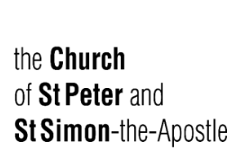
Fourth Sunday after the Epiphany
January 29, 2029

Welcome to the church of St Peter and St Simon-the-Apostle
Holy Eucharist at 9.15 am.
(In the Chapel of the Holy Spirit)
The service begins on page 67 of the Book of Common Prayer.

Choral Matins at 10:30 am.
Officiant & Preacher: The Reverend Canon Geoffrey Sangwine
Director of Music: Robin Davis / Organist: Johan van’t Hof
Welcome to the Church of St. Peter and St. Simon-the-Apostle.
The service begins on page 1 of the Book of Common Prayer.

The flowers in the sanctuary are given to the honour and glory of Almighty God
and in thanksgiving for the life of Alan Grant Simms
from Glenna, Isaak, Shirley and family.
___________________________________________________________________________
Prelude Folk Tune Percy Whitlock
Hymn 356 Ye Boundless Realms of Joy (CP 365) Darwall
Opening Sentences – BCP p. 1-2

Invitation to Confession – BCP p. 4

General Confession – BCP pp. 4-5 Please kneel or be seated
Officiant Almighty and most merciful Father,
All We have erred and strayed from thy ways like lost sheep,
we have followed too much the devices and desires of our own hearts,
we have offended against thy holy laws,
We have left undone those things which we ought to have done,
and we have done those things which we ought not to have done;
and there is no health in us. But thou, O Lord, have mercy upon us,
miserable offenders. Spare thou them, O God, which confess their faults.
Restore thou them that are penitent; according to thy promises
declared unto all people in Christ Jesu our Lord.
And grant, O most merciful Father, for his sake, that we may hereafter
live a godly, righteous, and sober life, to the glory of thy holy Name. Amen.

The Absolution – BCP p. 5
Officiant Almighty God, the Father of our Lord Jesus Christ, who desireth not the death of sinners, but rather that they may turn from their wickedness, and live, hath given power and commandment to his Ministers, to declare and pronounce to his people, being penitent, the Absolution and Remission of their sins. He pardoneth and absolveth all them that truly repent and unfeignedly believe his holy Gospel. Wherefore we beseech him to grant us true repentance and his Holy Spirit, that those things may please him which we do at this present, and that the rest of our life hereafter may be pure and holy; so that at the last we may come to his eternal joy; through Jesus Christ our Lord. Amen.

The Lord’s Prayer – BCP pp. 5-6
Officaint Our Father
who art in heaven, Hallowed be thy Name, Thy kingdom come,
Thy will be done, on earth as it is in heaven.
Give us this day our daily bread; And forgive us our trespasses,
As we forgive them that trespass against us; And lead us not into temptation,
But deliver us from evil. For thine is the kingdom,
the power, and the glory, For ever and ever. Amen.

Versicles & Responses – BCP p. 6
Officiant O Lord, open thou our lips;
All And our mouth shall show forth thy praise.
Officiant O God, make speed to save us;
All O Lord, make haste to help us. All stand.
Officiant Glory be to the Father, and to the Son, and to the Holy Ghost;
All As it was in the beginning, is now, and ever shall be, world without end. Amen.
Officiant Praise ye the Lord;
All The Lord’s Name be praised.
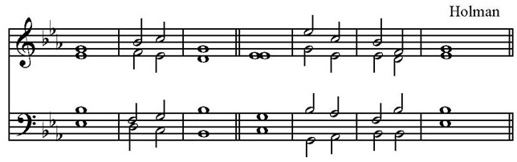
The Venite – Psalm 95 BCP pp. 6-7 Sung by all, standing.

The Lord hath manifested | forth his | glory: /
O | come | let us | worship.

O come, let us | sing unto ⋅ the | Lord: /
* let us heartily rejoice in the | strength of | our sal | vation.
Let us come before his | presence with | thanksgiving /
* and show ourselves | glad in | him with | psalms.
For the Lord is a | great | God /
* and a great | King a⋅bove | all | gods.
In his hand are all the | corners ⋅ of the | earth /
* and the | strength of ⋅ the | hills is ⋅ his | also.
The sea is | his and ⋅ he | made it /
* and his | hands pre | pared the ⋅ dry | land.
O come, let us worship and | fall | down /
* and | kneel be⋅fore the | Lord, our | Maker.
For he is the | Lord our | God /
* and we are the people of his pasture, | and the | sheep of ⋅ his | hand.
To-day, O that ye would | hear his | voice: /
* ‘Harden not your hearts as in the Provocation, and as in the day of Temp | tation | in the | wilderness;

When your fathers | tempted | me, /
* proved | me, and | saw my | works.

Forty years long was I grieved with that gene | ration, and | said, /
* “It is a people that do err in their hearts, for they | have not | known my | ways”;

Unto whom I | sware in my | wrath, /
* that they should not | enter | into my | rest.’

Glory be to the Father, and | to the | Son,
* and | to the | Holy | Ghost;
As it was in the beginning, is now, and | ever | shall be,
* world without | end. | A- | men.
The Lord hath manifested | forth his | glory: /
O | come | let us | worship.

The First Lesson Micah 6.1-8 Read by Paul Faulkner
Reader The first lesson is written in the 6th chapter of the Book of the prophet Micah,
beginning at the 1st verse.
Hear what the Lord says: Rise, plead your case before the mountains, and let the hills hear your voice. Hear, you mountains, the controversy of the Lord, and you enduring foundations of the earth; for the Lord has a controversy with his people, and he will contend with Israel. "O my people, what have I done to you? In what have I wearied you? Answer me! For I brought you up from the land of Egypt, and redeemed you from the house of slavery; and I sent before you Moses, Aaron, and Miriam. O my people, remember now what King Balak of Moab devised, what Balaam son of Beor answered him, and what happened from Shittim to Gilgal, that you may know the saving acts of the Lord." "With what shall I come before the Lord, and bow myself before God on high? Shall I come before him with burnt offerings, with calves a year old? Will the Lord be pleased with thousands of rams, with ten thousands of rivers of oil? Shall I give my firstborn for my transgression, the fruit of my body for the sin of my soul?" He has told you, O mortal, what is good; and what does the Lord require of you but to do justice, and to love kindness, and to walk humbly with your God?
Reader The word of the Lord.
All Thanks be to God.

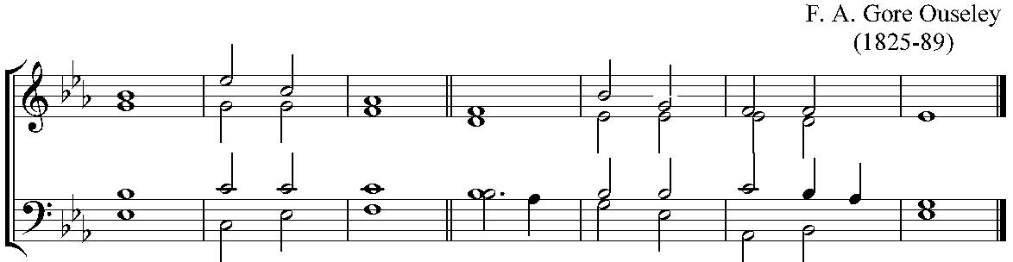
Psalm 15 Please remain seated

¹ Lord, who shall| dwell in thy | tabernacle?
or who shall rest up | on thy | holy | hill?
² Whoever leadeth an uncorrupt life, and doeth the | thing which ˖ is | right,
and | speaketh the | truth from their | heart.
³ They that hath used no deceit in their tongue, nor done evil | to | their | neighbour,
and | hath not | slandered their| neighbour.
⁴ In the eyes of God the ungodly | are de | spised,
but God maketh much of | them that | fear the | Lord.
⁵ They that sweareth unto their neighbour, and disap | ointeth them | not,
though it | were ˖ to their | own | hindrance.
⁶ They that hath not given their | money up-on | usury,
nor taken re | ward a | gainst the | innocent.
2nd ⁷ Whoso doeth | these things ˖ shall | never | fall.
Glory be to the Father, and | to the | Son , and | to the | Holy | Ghost;
As it was in the beginning, is now, and | ever | shall be
world without | end. A | - - | men.

The Second Lesson I Corinthians 1.18-31 Read by Paul Faulkner
Reader The second lesson is written in first chapter of the Letter of St Paul to the
Corinthians, beginning at the 18th verse.
The message about the cross is foolishness to those who are perishing, but to us who are being saved it is the power of God. For it is written, "I will destroy the wisdom of the wise, and the discernment of the discerning I will thwart." Where is the one who is wise? Where is the scribe? Where is the debater of this age? Has not God made foolish the wisdom of the world? For since, in the wisdom of God, the world did not know God through wisdom, God decided, through the foolishness of our proclamation, to save those who believe. For Jews demand signs and Greeks desire wisdom, but we proclaim Christ crucified, a stumbling block to Jews and foolishness to Gentiles, but to those who are the called, both Jews and Greeks, Christ the power of God and the wisdom of God. For God's foolishness is wiser than human wisdom, and God's weakness is stronger than human strength. Consider your own call, brothers and sisters: not many of you were wise by human standards, not many were powerful, not many were of noble birth. But God chose what is foolish in the world to shame the wise; God chose what is weak in the world to shame the strong; God chose what is low and despised in the world, things that are not, to reduce to nothing things that are, so that no one might boast in the presence of God. He is the source of your life in Christ Jesus, who became for us wisdom from God, and righteousness and sanctification and redemption, in order that, as it is written, "Let the one who boasts, boast in the Lord."
Reader The word of the Lord.
All Thanks be to God.

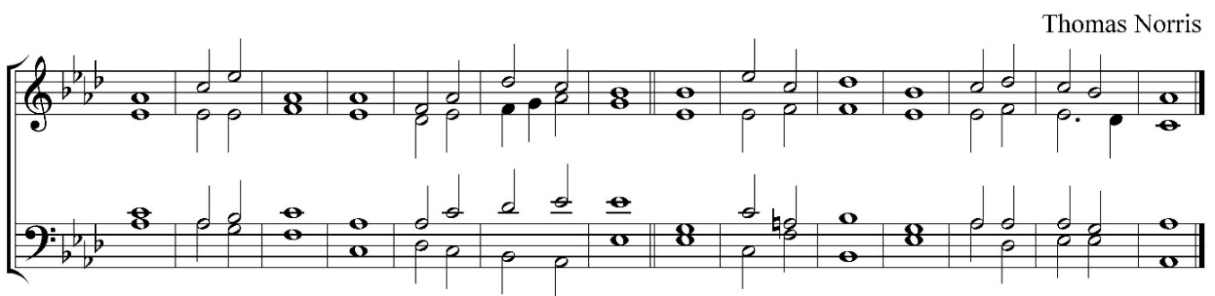
Te Deum – BCP pp. 7-9 Sung by all, standing

We praise ˈ thee, O ˈ God; / we acknowledge ˈ thee to ˈ be the ˈ Lord.
All the ˈ earth doth ˈ worship thee, / the ˈ Father ˈ ever ˈ lasting.
To thee all angels ˈ cry aˈloud / the heavens and ˈ all the ˈ powers thereˈin.
To thee ˈ cherubim and ˈ seraphim / conˈtinualˈly do ˈ cry.
Holy ˈ holy ˈ holy / Lord ˈ God ˈ of ˈ hosts;
Heaven and ˈ earth are ˈ full / of the ˈ majes⋅ty ˈ of thy ˈ glory.
The glorious company of the aˈpostles ˈ praise thee /
the goodly fellowship ˈ of the ˈ prophets ˈ praise thee;
The noble army of ˈ martyrs ˈ praise thee, /
The holy church throughout all the world ˈ doth acˈknowledge ˈ thee,
2nd The Father, of an ˈ infinite ˈ majesty /
thine honourable, true and only Son; also the ˈ Holy ˈ Ghost, the ˈ Comforter.

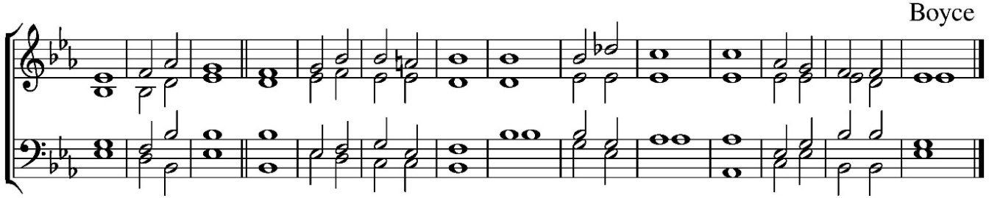

Thou art the King of ˈ glory, O ˈ Christ. /
Thou art the everˈlasting ˈ Son of ⋅ the ˈ Father.
When thou tookest upon thee to deˈliver ˈ man /
Thou didst not abˈhor the ˈ Virgin’s ˈ womb.
When thou hadst overcome the ˈ sharpness of ˈ death /
thou didst open the kingdom of ˈ heaven to ˈ all beˈlievers.
Thou sittest at the right hand of God, in the ˈ glory ⋅ of the ˈ Father. /
We believe that thou shalt ˈ come to ˈ be our ˈ judge.
We therefore pray thee, ˈ help thy ˈ servants /
whom thou hast redeemed ˈ with thy ˈ precious ˈ blood.
Make them to be numbered ˈ with thy ˈ saints / in ˈ glory ˈ everˈlasting.
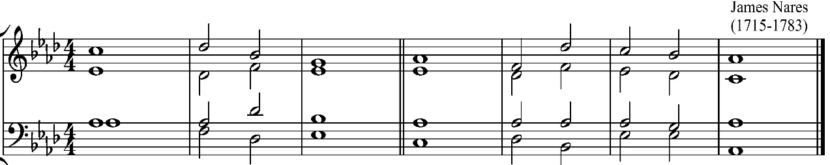

O Lord save thy people and ˈ bless thine ˈ heritage; /
Govern them and ˈ lift them ˈ up for ˈ ever.
Day by day we ˈ magni-fy ˈ thee; / and we worship thy Name, ˈ ever ˈ world with-out ˈ end.
Vouchsafe O Lord to keep us this ˈ day with-out ˈ sin. /
O Lord have mercy up ˈ on us, have ˈ mercy up ˈ on us.
O Lord let thy mercy lighten upon us, as our ˈ trust is ⋅ in ˈ thee. /
O Lord, in thee have I trusted: let me ˈ never ˈ be con ˈ founded.

Third Lesson Matthew 5.1-12
Reader The third lesson is written in 5th chapter of the Gospel according to St Matthew, beginning at the 5th verse.
When Jesus saw the crowds, he went up the mountain; and after he sat down, his disciples came to him. Then he began to speak, and taught them, saying: ‘Blessed are the poor in spirit, for theirs is the kingdom of heaven. ‘Blessed are those who mourn, for they will be comforted. ‘Blessed are the meek, for they will inherit the earth. ‘Blessed are those who hunger and thirst for righteousness, for they will be filled. ‘Blessed are the merciful, for they will receive mercy. ‘Blessed are the pure in heart, for they will see God. ‘Blessed are the peacemakers, for they will be called children of God. ‘Blessed are those who are persecuted for righteousness’ sake, for theirs is the kingdom of heaven. ‘Blessed are you when people revile you and persecute you and utter all kinds of evil against you falsely on my account. Rejoice and be glad, for your reward is great in heaven, for in the same way they persecuted the prophets who were before you.
Reader The Word of the Lord.
All Thanks be to God.

Jubilate Deo Sung by all, standing. Jonathan Battishill

¹ O be joyful in the Lord, | all ye | lands:
* serve the Lord with gladness, and come before his | presence | with a | song.
² Be ye sure that the | Lord ⋅ he is | God;
* it is he that hath made us, and not we ourselves; we are his people, |
and the | sheep of ⋅ his | pasture.
³ O go your way into his gates with thanksgiving, and into his | courts with | praise;
* be thankful unto him, | and speak | good of ⋅ his | Name.
⁴ For the Lord is gracious, his mercy is | ever | lasting;
* and his truth endureth from gene | ration to | gene | ration.

Glory be to the Father, and | to the | Son, * and | to the | Holy | Ghost;
As it was in the beginning, is now, and | ever | shall be,
* world without | end. A | - - | men.
The Apostles’ Creed – BCP pp. 10-11
Officiant I believe in God
All the Father Almighty, maker of heaven and earth: and in Jesus Christ his only Son our Lord, who was conceived by the Holy Ghost, born of the Virgin Mary, suffered under Pontius Pilate, was crucified, dead, and buried: he descended into hell; the third day he rose again from the dead; he ascended into heaven, and sitteth on the right hand of God the Father Almighty; from thence he shall come to judge the quick and the dead. I believe in the Holy Ghost; the holy Catholic Church; the Communion of Saints; the Forgiveness of sins; the Resurrection of the body, and the Life everlasting. Amen.
Officiant The Lord be with you;
All And with thy spirit.
Officiant Let us pray. Please kneel or be seated.
Officiant Lord, have mercy upon us.
All Christ, have mercy upon us.
Officiant Lord, have mercy upon us.

Officiant Our Father
All who art in heaven, hallowed be thy name, thy kingdom come,
thy will be done, on earth as it is in heaven.
Give us this day our daily bread; and forgive us our trespasses,
as we forgive them that trespass against us; and lead us not into temptation,
but deliver us from evil. Amen.

Officiant O Lord, show thy mercy upon us;
All And grant us thy salvation.
Officiant O Lord, save the King;
All And mercifully hear us when we call upon thee.
Officiant Endue thy ministers with righteousness;
All And make thy chosen people joyful.
Officiant O Lord, save thy people;
All And bless thine inheritance.
Officiant Give peace in our time, O Lord;
All And evermore mightily defend us.
Officiant O God, make clean our hearts within us;
All And take not thy Holy Spirit from us.

The Collects
Officiant O GOD, who knowest us to be set in the midst of so many and great dangers, that by reason of the frailty of our nature we cannot always stand upright: Grant to us such strength and protection, as may support us in all dangers, and carry us through all temptations; through Jesus Christ our Lord. Amen. Fourth Sunday after the Epiphany
Officiant O GOD, who art the author of peace and lover of concord, in knowledge of whom standeth our eternal life, whose service is perfect freedom: defend us thy humble servants in all assaults of our enemies; that we, surely trusting in thy defence, may not fear the power of any adversaries; through the might of Jesus Christ our Lord. Amen. Collect for Peace
Officiant O LORD, our heavenly Father, Almighty and everlasting God, who hast safely brought us to the beginning of this day: defend us in the same with thy mighty power; and grant that this day we fall into no sin, neither run into any kind of danger; but that all our doings may be ordered by thy governance, to do always that is righteous in thy sight; through Jesus Christ our Lord. Amen. Collect for Grace

Anthem The Beatitudes Derek Holman
Blessed are the poor in spirit, for theirs is the kingdom of heaven.
Blessed are they that mourn, for they shall be comforted.
Blessed are the meek, for they shall inherit the earth.
Blessed are they which do hunger and thirst for what is right, for they shall be filled.
Blessed are the merciful, for they shall obtain mercy.
Blessed are the pure in heart, for they shall see God.
Blessed are the peacemakers, for they shall be called children of God.
Blessed are they which are persecuted for righteousness’ sake, for theirs is the kingdom of heaven. Blessed are ye, when men shall revile you and persecute you, and shall say all manner of evil against you falsely for my sake.
Rejoice, and be exceeding glad, for your reward is great in heav’n, for so persecuted they the prophets which were before you.
Sermon The Reverend Canon Geoffrey Sangwine
Hymn 439 Blest Are the Pure in Heart Franconia
During the hymn a collection will taken.
Prayers – Led by Spencer Higgins Please kneel or be seated.
General Thanksgiving – BCP pp. 13-14
Officiant Almighty God,
All Father of all mercies, we thine unworthy servants do give thee most humble and hearty thanks for all thy goodness and loving-kindness to us and to all people. We bless thee for our creation, preservation, and all the blessings of this life; but above all for thine inestimable love in the redemption of the world by our Lord Jesus Christ; for the means of grace, and for the hope of glory. And we beseech thee, give us that due sense of all thy mercies, that our hearts may be unfeignedly thankful, and that we show forth thy praise, not only with our lips, but in our lives; by giving up ourselves to thy service, and by walking before thee in holiness and righteousness all our days; through Jesus Christ our Lord, to whom, with thee and the Holy Ghost, be all honour and glory, world without end. Amen.
Prayer of St Chrysostom – BCP p. 15
Officiant Almighty God, who hast given us grace at this time with one accord to make our common supplications unto thee; and dost promise that when two or three are gathered together in thy Name thou wilt grant their requests: Fulfil now, O Lord, the desires and petitions of thy servants, as may be most expedient for them; granting us in this world knowledge of thy truth, and in the world to come life everlasting. Amen.
The Grace
All The grace of our Lord Jesus Christ, and the love of God,
and the fellowship of the Holy Spirit, be with us all evermore. Amen.
Announcements
Hymn 598 Go to the World Engelberg
Postlude Sei gegrüsset, Jesu gütig (Variation I and XI) BWV 768 J.S. Bach
CCLI License Number: 20651739
In our Prayers this Week
The Anglican Communion The Church of Pakistan (United).
Diocesan Cycle of Prayer Holland Deanery.
Outreach & Advocacy Cycle of Prayer Pray for Grace Church, Markham, its monthly community lunch programme, its Community Garden, its commitment to advocacy and education regarding Indigenous, LGBTQ+ and anti-racism issues; and its ongoing support of refugee sponsorship through AURA;
for Grace Church, Scarborough, its monthly community lunch and cooking club, and its support of the Good Food Box;
and for the Parish of Haliburton, and its support of the Haliburton Youth Hub.
Parish Cycle Yvette Robinson, Cynthia Rogers, Cynthia Roosevelt, Stephen & Alison Rupp.
Home Bound Parishioners Joyce Brighty, Nancy Byers, Alice Fox, Dennis Gittens, Lorraine Griffith, Sabrina Hogan, George Petricko, Lucy Simons, Miriam Smart, Vernita Theobolds, Barbara Towe, Lila Vamosi, Daphne Webster.

The Church of St. Peter and St. Simon-the-Apostle
525 Bloor St E, Toronto, ON M4W 1J1
416.923.8714 www.stpeterstsimon.ca www.facebook.com/stpeterstsimons
Incumbent The Reverend Canon Geoffrey Sangwine, ext. 202
incumbent@stpeterstsimon.ca; Mobile: 416.720.2099

